QIRC ECR SEED GRANT SCHEME APPLICATION FORM 2027
- PROJECT TITLE

- APPLICANT NAMES (Insert rows as required to include more co-investigators)

 | Title | Name | Appointment, Institute | Contact (email)
UQ Lead Investigator
QIMRB Lead Investigator
Co-investigator

- EARLY-CAREER RESEARCHER (ECR) SEED GRANT ELIGIBILITY
QIRC Seed Grants are specifically set aside for ECRs. Both lead investigators must qualify as ECRs. Additional co-investigators do not need to be ECRs.

Do both of your lead investigators qualify as Early-Career Researchers (<10 years since award of PhD, allowing for career interruptions)?

☐ Yes (please fill out table below) ☐ No (you are not eligible for this round)

UQ Lead Investigator | QIMRB Lead Investigator
Year PhD awarded: | Year PhD awarded:
If >10 years since award of PhD, please outline academic career interruptions since the award of your PhD: | If >10 years since award of PhD, please outline academic career interruptions since the award of your PhD:

- RESEARCH AREA

Infectious diseases and vaccines ☐
Inflammation and tissue homeostasis ☐
Mucosal immunology and innate immunity ☐
Cancer immunology and immunotherapy ☐
Allergy and autoimmunity ☐
Systems immunology and new technology ☐

- APPLICATION SUMMARY

BACKGROUND (Max 500 words)

AIMS (Max 200 words)

HYPOTHESES (Max 100 words)

RESEARCH PLAN (Max 500 words)

SIGNIFICANCE AND INNOVATION (Max 300 words)

COLLABORATIVE NETWORK (Max 200 words)
How will this application facilitate collaboration between UQ and QIMR Berghofer (and external partners if applicable)?

REFERENCES

- TRACK RECORD (Please provide track record for the lead investigators ONLY)

UQ Lead Investigator
TOP 5 PUBLICATIONS IN THE LAST 5 YEARS
(include reasons that these have been selected)

GRANTS
PRESENTATIONS
MENTORING (Max 200 words)
Has the UQ Lead Investigator been successful in receiving a QIRC Seed Grant as one of the lead investigators in a previous funding round?

☐ Yes (please attach the relevant seed grant report to your application) ☐ No

QIMRB Lead Investigator
TOP 5 PUBLICATIONS IN THE LAST 5 YEARS
(include reasons that these have been selected)

GRANTS
PRESENTATIONS
MENTORING (Max 200 words)
Has the QIMR Berghofer Lead Investigator been successful in receiving a QIRC Seed Grant as one of the lead investigators in a previous funding round?

☐ Yes (please attach the relevant seed grant report to your application) ☐ No

- BUDGET
Maximum budget is $30,000 over one year. Funding should be shared approximately equally between the two collaborating institutions, with any variation justified.

(DOUBLE CLICK TO INSERT DATA)
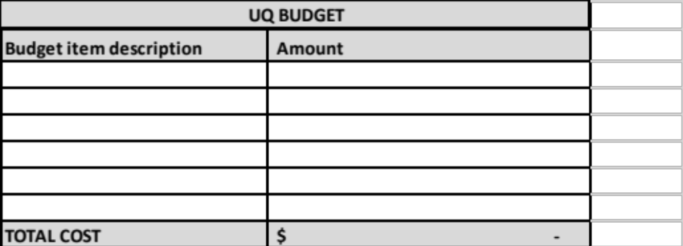
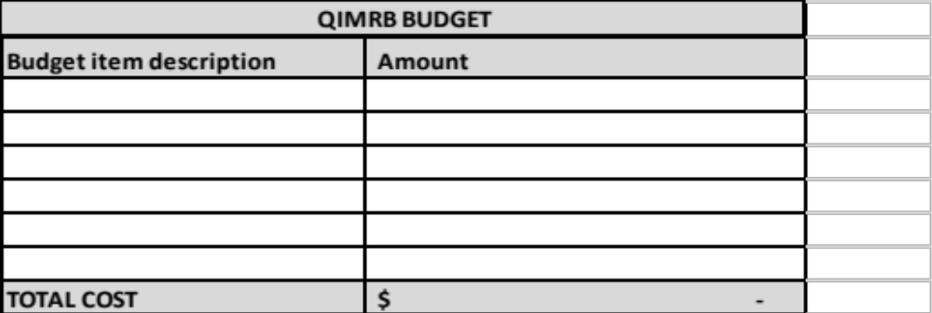

- CERTIFICATION OF LEAD INVESTIGATORS
I certify that:
- To the best of my knowledge, all the details on this application form are true and complete.
- I will comply with all necessary policies and procedures in discharging my responsibilities under this grant.
- I understand and agree that all ethical clearances must be met before the proposed research can commence.
- In submitting this application, I consent to its referral to the QIRC assessors for consideration.
- All parties identified in the application have agreed to its submission and proper inquiries have been made and I am satisfied that all investigators on this proposal meet the eligibility criteria as specified.
Signature of Applicant 1 ______________________________ Date____________________

Signature of Applicant 2 ______________________________ Date____________________

Applications must be submitted via email as a PDF attachment to qirc@uq.edu.au by 5:00pm, 9 November 2026.

